**UNIVERSITY OF DAR ES SALAAM**



COLLEGE OF INFORMATION AND COMMUNICATION TECHNOLOGIES

(CoICT)

DEPARTMENT OF COMPUTER SCIENCE AND ENGINEERING

**FINAL YEAR PROJECT SEMESTER REPORT**

**PROJECT TITLE:** PATIENT INFORMATION MANAGEMENT SYSTEM

**SUB-MODULE:** PHARMACEUTICAL INVENTORY MANAGEMENT MODULE

**STUDENT NAME:** NASSORO MOHAMED A

**PROGRAMME:** BSC WITH COMPUTER SCIENCE

**SUPERVISOR:** DR ELLEN KALINGA

**COURSE NAME:** FINAL YEAR PROJECT

**SUPERVISOR**

Name______________________________ Signature______________________________

# DECLARATION

I NASSORO MOHAMED A with registration number 2017-04-12255 taking Bachelor Of Science With Computer Science Collage of CoICT, university of Dar es Salaam I declared under my FYP-Supervisor DR ELLEN KALINGA, I written this report by considering laws and regulation of FYP report writing.

**REPORT APPROVED BY;**

**SUPERVISOR**

Name______________________________ Signature______________________________

**STUDENT**

Name______________________________ Signature_____________________

Date______________________

# ACKNOWLEDGEMENT

My special thanks for Almighty God who give me a wide chance to participate effectively in FINAL YEAR PROJECT and with his power he gave me the strength to accomplish it. Special gratitude to my supervisor Dr. Ellen Kalinga , COICT Collage and the Final year project Coordinator as well as my Final Year Project Team whose were with me throughout to my FINAL YEAR PROJECT by providing different materials.

Special thanks to Dr. Ellen Kalinga my FYP-Supervisor from University of Dar-es-Salaam (COICT) and my fellow students as well as my Final Year Project Team for his great participation and contribution in report preparation, weekly consultation and other activities.

# LIST OF ABBREVIATIONS AND ACRONYMS

CT Scan - Computer Tomography scan

HER - Electronic Health Records

EMR - Electronic Medical Records

Lab – Clinical Laboratory

ROS – Review of Systems

MNH - Muhimbili National Hospital

MRD – Medical Record Department

MRI – Medical Resonance Imaging

DFD - Data Flow Diagram

COICT - Collage of Information Communication Technology

UDSM - University of Dar es salaam

# ABSTRACT

Pharmaceutical Information management system is one of the most essential tools that are mostly required in PATIENT INFORMATION MANAGEMENT SYSTEM in order to increase efficiency and effective performance in health sector especially on the hospital drug issues; it is mostly used to manage medicine related activities such as medical inventory, record keeping, report management as well as managing the drug stock and information of the expired medicines. Many hospital pharmaceutical stock in Tanzania are still operating manually; they don’t have adequate software to manage their daily activities. It needs the pharmacist assistant to check the expired date of the medicine twice a week, and it can take a lot of time to find out whether certain medicine are out of stock. In this project we tried to develop a computerized and web based Pharmaceutical Information management system. Our main intention is to allow this application to be used in order to maximize controlling, managing and monitoring all drugs cycle of drugs. This system is designed to overcome all challenges related to the management of medicine that were used to be handled locally and manually. Pharmacy inventory has its own significance to the all pharmaceutical hospital store. Using this system, it will help us to records all patient, employees, balance stock, etc. It will manage all activities it will also minimizing the risk of getting drugs lost by any means because all processes/issues are recorded to the system.

Pharmaceutical Inventory management module is designed to improve the accuracy, enhance safety and efficiency in the pharmaceutical store. It is a computer based system which helps the stakeholders to improve inventory management, cost, medical safety etc. Pharmaceutical Inventory management system was developed to ensure the security of information and reliability of Pharmacy records, reliability of the drugs to the patients when accessing medical services. The information gathered during the data collection was properly analyzed and the results provided the basis for the new system. The system was tested and found to be functional and the outputs produced by this system were encouraging. The application will hence reduce the loss of information unlike the existing system and also information will be processed fast, also remove all inconvenience around medical issues especially in the provision of medicine services.

# TABLE OF CONTENTS

DECLARATION i

ACKNOWLEDGEMENT ii

LIST OF ABBREVIATIONS AND ACRONYMS iii

ABSTRACT iv

TABLE OF CONTENTS v

LIST OF FIGURES i

LIST OF TABLES i

CHAPTER ONE: INTRODUCTION 2

1.1 Background 2

1.2 Problem statement 4

1.3 Objectives of the Module 5

1.3.1 Main Objective of Module 5

1.3.2 Specific Objectives 5

1.4 Significance of the project 5

1.5 Scope and Limitation of module 6

1.6 Organization of the Project 7

CHAPTER TWO: LITERATURE REVIEW 8

2.1 Existing Systems 8

2.1.1 Traditional paper based record keeping 8

2.1.2 Flow of Information in Paper Based Record Keeping 9

2.1.3 Electronic Medical Record System 10

2.2 Proposed System 11

CHAPTER THREE: METHODOLOGY 13

3.1 Waterfall Software Development Model 13

3.2 Waterfall Methodology Steps 13

3.2.1 Requirement Gathering and analysis 14

3.2.2 System Design 14

3.2.3 Implementation 14

3.2.4 Integration and Testing 15

3.3 Data Collection 15

3.3.1 Interview 15

3.3.2 Observation 16

CHAPTER FOUR: PIMM SYSTEM ANALYSIS AND DESIGN 17

4.1 Requirement Specification for PIMM 17

4.1.1 PIMM Functional Requirements 17

4.1.2 Non Functional Requirements 18

i. Usability 18

ii. Compatibility 18

iii. Responsiveness 18

iv. Security 18

4.1.3 Use Case Analysis 18

4.1.4 Use cases descriptions 21

4.1.5 Class diagram analysis 24

4.2 System Design 24

4.2.1 Data Modeling 24

4.2.2 Data Flow 24

4.2.3 Entity Relationship Diagram 25

4.2.4 Physical database model 26

4.2.5 Activity Diagram 27

CHAPTER FIVE: CONCLUSION AND RECOMMENDATIONS 28

5.1 Conclusion 28

5.2 Recommendations 28

REFERENCES 29

APPENDICES 30

Appendix I: Project Schedule 30

Appendix II: Estimated Cost of the project 30

Appendix III: Sample Interview questions (interview with a physician) 31

# LIST OF FIGURES

Figure 1.1: Hospital activities 3

Figure 1.2: PIMS major component/module 4

Figure 2.1: Paper based record keeping in hospitals (Muhimbili National Hospital, 2018) 9

Figure 2.2: Flow of Medical Records During Doctor Visit 10

Figure 2.3: Block Diagram of the Proposed System 11

Figure 3.1: Waterfall Methodology Steps 14

Figure 4.1: Use case diagram for Patient/User 19

Figure 4.2 Use Case Diagram for Hospital/Pharmacy in Charge or Manager 19

Figure 4.3 Use case Diagram for Doctor 20

Figure 4.4: Use Case Diagram for pharmacist 20

Figure 4.5: Class Diagram 24

Figure 4.3: Level 0 Data Flow Diagram 25

Figure 4.4: Level 1 Data Flow Diagram 25

Figure 4.5: Entity Relationship Diagram for a Conceptual Database Model 26

Figure 4.6: Physical Database Model 27

Figure 4.7: Activity Diagram for Hospital Visit 27

# LIST OF TABLES

Table 4.1: PIMM Functional Requirements 17

# CHAPTER ONE: INTRODUCTION

## Background

Hospital is an institution that provides medical and surgical treatment as well as nursing care for the sick or injured people. On other words Hospital is a place where people who are ill or injured are treated and taken care by nurses or doctors. Examples of hospitals in Dar es salaam are Muhimbili National Hospital, Mwananyamala Hospital, Agha khan Hospital, TMJ Hospital and et cetera. In hospitals there are several services provided such as Laboratory services, Mental health care, Drug treatment, Surgery, Diagnosis and testing, Accident and emergency services, Treatment and therapy.

Hospital visit activity by patients can be summarized as follows: Firstly when a patient arrives in the hospital (see Figure 1.1), he or she will go at reception, receptionist working in a hospital will fill a particular file for a patient here a patient is required to provide his or her personal information including names, Residence, phone number and Age, then the receptionist arranges the appointment with a Doctor. Then the receptionist send patient’s information to the doctors so as a doctor can attend the patient, then after seeing a doctor a patient will be directed to go To the Laboratory for testing and the laboratory technician receives patient’s information from a doctor through or via the hospital system or manually for hospital which have no information system, after testing laboratory technician send back the feedback from the tests performed, the tests are used to diagnose disease , determine appropriate therapies and amount of drugs to be prescribed to a patient.

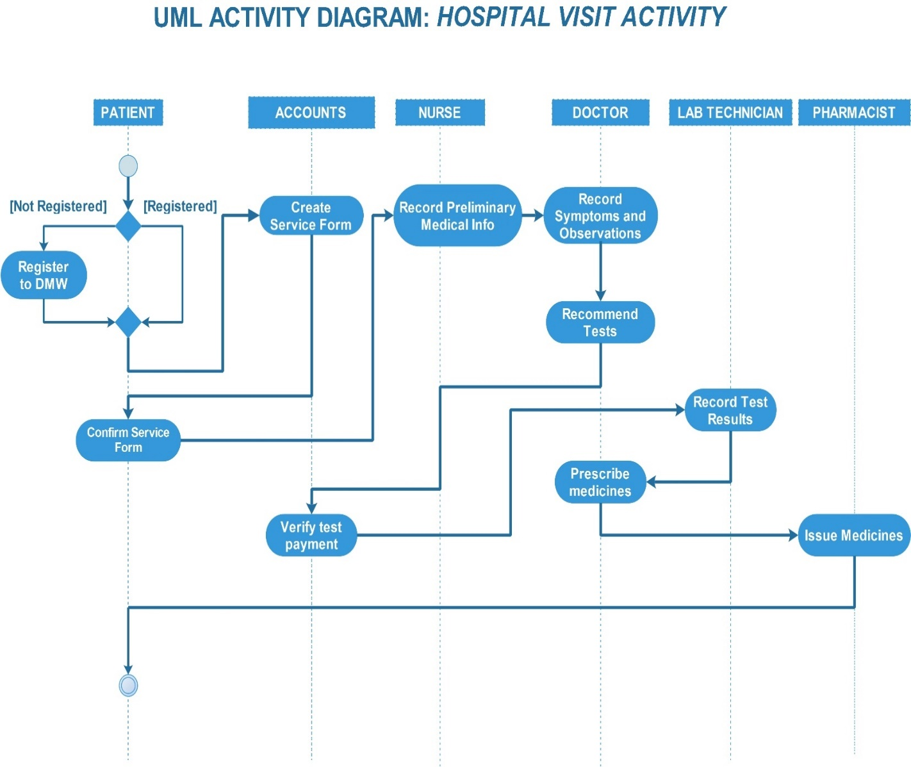

Figure 1.1: Hospital activities

It is important that doctors may be able to offer at-risk patients the opportunity for individualized testing and treatment to actually prevent disease. However, this ability will be contingent upon obtaining a detailed medical and medicine inventory history. Patients leave data scattered across various organizations as life events take them away from one provider's data silo and into another. In doing so they lose easy access to past data, as the provider, not the patient, generally retains primary stewardship.

As patient volume increases and encounter times become shorter, it is critical for clinicians to establish a working diagnosis in a timely manner. With the advent of advanced technological equipment and rising healthcare costs, it is even more important to be selective about the use of these tools and to base testing decisions on the specific findings noted in the patient's clinical evaluation. Therefore, the clinical history and physical exam are critical to the diagnostic process and often provide more information than can be gained by broad testing strategies.

Most patients come in for appointments with multiple concerns, which can make it even more challenging to focus the encounter without losing important information regarding the patient's healthcare issues. If the key to the patient's diagnosis lies within the history, which will in turn determine the type of physical exam, then refining the art of history taking is the first step to an accurate diagnosis.

The following in Figure 1.2 are the major components of the Patient Information Management System according to the needs of the system and Hospital Activity in the figure 1.1 above

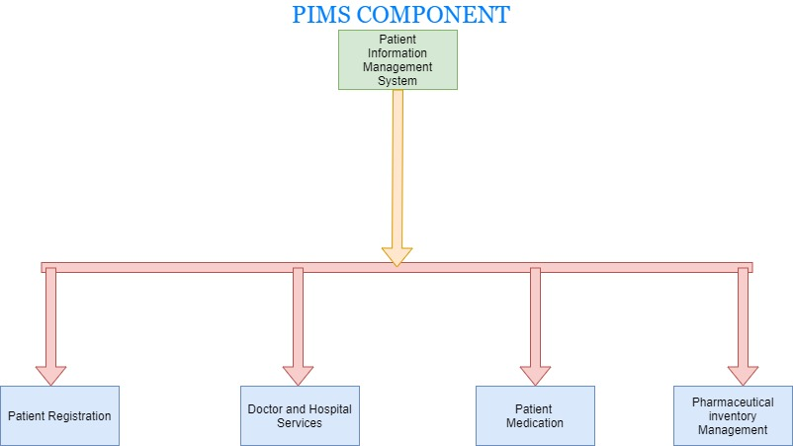

Figure 1.2: PIMS major component/module

This project is dealing with the Pharmaceutical Inventory Management Module (PIMM), as part of the Patient Information Management System

## Problem statement

Medical practitioners need information about previous diagnoses, treatments and prescriptions in order to note the progress made with previous treatments and how to move forward. Existing methods of record keeping has resulted into medical records that are dispersed across different medical facilities and are often incomplete contributing to unnecessary, repeated testing, treatments and **misdiagnosis** as well as poor monitoring and managing of the drugs inventory also challenges in the easy accessibility of the drugs from one hospital to another.

There is high deficiency and low performance in Managing, monitoring and controlling the distribution of medicine/drugs (Pharmaceutical services)in health sector especially in Government Hospitals. Because of high cheating, challenges and problems that facing in the pharmaceutical issues such as poor pharmaceutical services to the society that lead many complains from the society to the health sector but also may cause the lost of people due to lack of medicine/drugs services.

## Objectives of the Module

### Main Objective of Module

The overall objective of this project is to develop Pharmaceutical Inventory Management Module (PIMM) module.

### Specific Objectives

1. To gather and analysis Requirement for Pharmaceutical Inventory Management Module
2. To design the Pharmaceutical Inventory Management Module making us of the analysed requirements
3. To Implement the designed Pharmaceutical Inventory Management Module
4. To test and integration Pharmaceutical Inventory Management Module with other system components for a complete system

## Significance of the project

Significance of the project has been group into two: General for the whole patient information management system and for Pharmaceutical Inventory Management Module. General significances include:

1. The system will be effective when extracting medical data for the examination of possible trends towards specific types of diseaseto determine whether you could benefit from preventive measures to lower your health risks.
2. Since patient’s profiles can be interconnected, your family’s health history can be helpful in determining which tests and screenings are best for you.
3. Continuity of healthcare:Health professionals can share relevant patient information and documentation
4. Data from the system can be used anonymously for statistical reporting.
5. The system will reduce the risk of malpractice
6. The system will increase efficient in manage and monitoring the inventory of drugs in the system
7. To improve accessibility of the reliable data in the fastest way

The significance of this module are:

1. To improve monitoring, managing, controlling of medicine in all level
2. To reduce cheating in the health sector and increase efficiency in that sector at all.
3. To alleviate various complaints in the pharmaceutical sector especially at various public hospitals
4. Also through this system will help to increase efficiency and convenience in the distribution of medicines in different areas according to the specific needs of the respective areas
5. To improve accessibility of the reliable data in the fastest way

## Scope and Limitation of module

The PIMS it could be a combination of web base system and mobile app system (for end user/patient) for the efficiency in uses of the system. The user and doctor of this system is being able to manage, control and monitor all necessary activities by requesting the drugs to the pharmacy shop via system. The information management that provided by the system is a great advantage to reduce records errors associated with pharmacy stock.

The system is handling all aspects of the inventory control function. It allow the Administrator, Managers and Stock Managers to records new batches of drugs delete obsolete drugs and modify the current dosage and indications of a drug in the database.

Furthermore, the system will make the process of stock replenishment to be easily. On the other hand, PIMS is able to generate reports on the list of drugs in the stock for a given period of time. Also a system allow to know expire date of drugs from early expire date to late expired in the stock. Although a Pharmacist is not able to insert, delete, or update any items to database because he/she has no authority to do so, even to view or print any report, but the system allow him/her to view requested drugs and to see which drugs they are release at the time.

## Organization of the Project

Report follow the report format that was released by the Final year project (FYP) coordinator and I was try to explain each part of the project according to the needs of the project in clear way such that:

In the introduction part I was explain the following parts such as General introduction that cover what the system does and what are the component of the system other part that was explained in chapter one are problem statement and project significance, objectives and scope and limitation

In chapter two I explain all about literature review such as existing or related system ,weakness of the existing system as well as what are the proposed system. In chapter three there is the methodology used for developing the proposed system in my report I choose the waterfall methodology also there some brief on why am using waterfall model rather than using other model.

In chapter four there is a system analysis and design first I explain the Requirement Engineering (i.e. data collection and data analysis) as well as explain the system analysis and modeling by drawing a use case and class diagram lastly in this chapter I was explaining about system design by drawing the DFD diagram and Conceptual Database Design .

# CHAPTER TWO: LITERATURE REVIEW

## Existing Systems

### Traditional paper based record keeping

The traditional method of keeping records that is used in most of the hospitals across Tanzania is the manual method involving papers and books. Files of papers are piled together, in stashes tied with some ropes organized in units, which are defined by the date of admission of the patients. Files from all departments – as long as the people were admitted on the same day – are kept together in one mound.

One of the important record that the hospital keep have is the Patient Chart, which is a booklet containing the detailed story of a person and their illness. This is the way data is recorded and stored in these booklets. Doctors record detailed notes and personal details, including the symptoms that brought the patient to the hospital in the first place, past medical history, and also a social history to help make a diagnosis.

This is usually followed by a full body examination, and then a doctor makes a tentative diagnosis and starts emergency treatment while awaiting confirmatory results from imaging or the laboratory. A patient is then followed up on the ward daily, monitoring progress until the patient improves, goes home, and gets worse or dies.

For patients who spend a long time in hospital, sometimes up to 3 or 4 booklets will be used. This is a lot of data, most of which is largely inaccessible. This data is property of the hospital and is not freely sharable with the patient or their primary caregivers. Figure 2.1 shows the existing sample of patients filings.

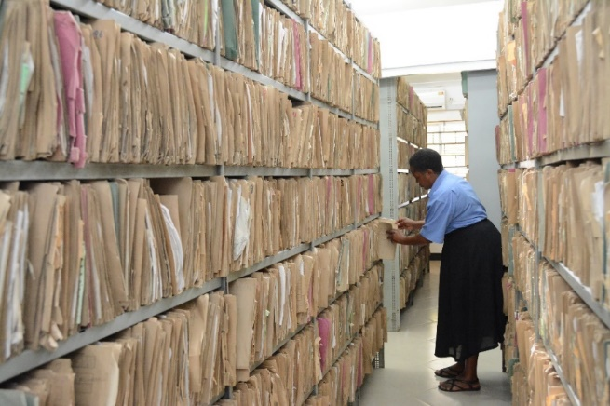

Figure 2.1: Paper based record keeping in hospitals (Muhimbili National Hospital, 2018)

### Flow of Information in Paper Based Record Keeping

In a meeting between a patient with a physician to get health advice or treatment for a symptom or condition the following process happens. A patient typically presents a set of complaints (the symptoms) to the physician, who then performs a diagnostic procedure, which generally includes obtaining further information about the patient's symptoms, previous state of health, living conditions, and so forth.

The physician then makes a review of systems (ROS) or systems inquiry, which is a set of ordered questions about each major body system in order: general (such as weight loss), endocrine, cardio-respiratory, etc. Next comes the actual physical examination and other medical tests; the findings are recorded in papers, leading to a list of possible diagnoses.

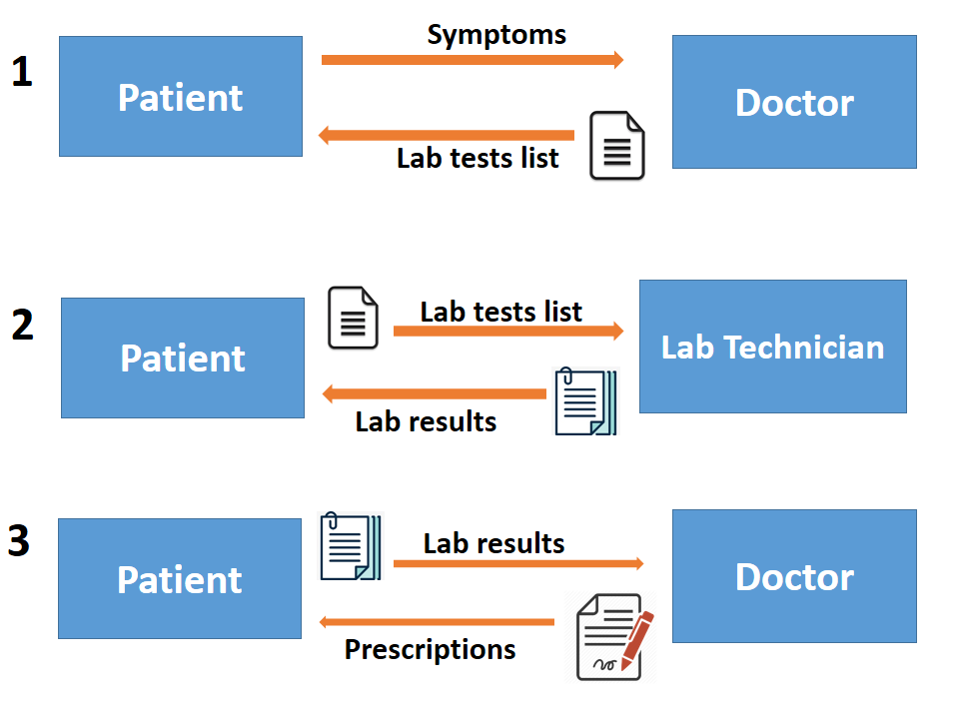

Figure 2.2: Flow of Medical Records During Doctor Visit

Limitation of paper based record keeping

1. Medical records are dispersed across different medical facilities, It is difficult to put together a complete history
2. Doctor’s access to medical records is limited by location and office hours. This can impact patient’s health in unusual circumstances, such as in an emergency procedure or when vital medication is misplaced
3. Unclear communication between consultants and referring physicians, resulting in a lack of follow through with evaluation and treatment plans.

### Electronic Medical Record System

Electronic medical records (EMRs) are digital versions of the paper charts in clinician offices, clinics, and hospitals (Mullins, 2015). EMRs contain notes and information collected by and for the clinicians in that office, clinic, or hospital and are mostly used by providers for diagnosis and treatment. EMRs are more valuable than paper records because they enable providers to track data over time, identify patients for preventive visits and screenings, monitor patients, and improve health care quality

Limitation of Electronic medical records

1. Potential Privacy and Security Issues. EMR systems are vulnerable to hacking, which means sensitive patient data could fall into the wrong hands (Ayres, 2018).
2. The record are focused on billings of the services provided
3. The system is not interoperable, patients has to register on multiple hospitals

## Proposed System

A proposed system is a decentralized platform that enables secure, fast and transparent exchange and usage of medical and medicine data. The proposed system will use block chain technology to create a user-focused electronic health record and maintain a single true version of the user’s data.

The system will enable users to give conditional access to different healthcare agents such as doctors, hospitals, laboratories, pharmacists and insurers to interact as they see fit.

Each interaction with their medical data is auditable, transparent and secure, and will be recorded as a transaction on System’s distributed ledger. During this process, the patient’s privacy is protected at all times. The system will be built on the permission-based hyper ledger Fabric architecture which will allows varying access levels.

***Users will control who can view their records, how much they see and for what length of time.***

Users will use a software to access and update their data. Also the same software will be used for granting others permission to access user’s data

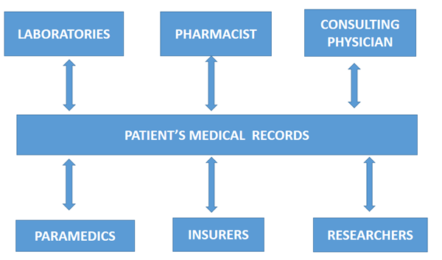

Figure 2.3: Block Diagram of the Proposed System

Strength of proposed system

1. The system will provide 24/7 access to patients records and lab results from any location
2. The system will provide access to complete medical information about a patient, helping in more accurate diagnosis and treatment
3. Helps avoid redundancy and unnecessary prescriptions
4. Increase efficient in manage and monitoring drugs inventory

# CHAPTER THREE: METHODOLOGY

## Waterfall Software Development Model

System development methodology chosen is waterfall methodology. The waterfall model is a plan driven process in principle, all of the process activities are planned and schedule before starting work on them (Sommerville, 2011, p.30) . The outcome of one phase acts as the input for the next phase sequentially. This means that any phase in the development process begins only if the previous phase is complete. The waterfall model is a sequential design process in which progress is seen as flowing steadily downwards.

Reasons for using waterfall:

1. The requirements for the medical record keeping system are known
2. As this is a security critical system, system architecture will be determined early
3. Completion date for this project is fixed

## Waterfall Methodology Steps

By using waterfall methodology, each stage in development of this project will finish before the next one can begin. There will also be a stage gate between consecutive stages. For example, requirements will be reviewed and approved before design begins. The stages of waterfall methodology are as follows:

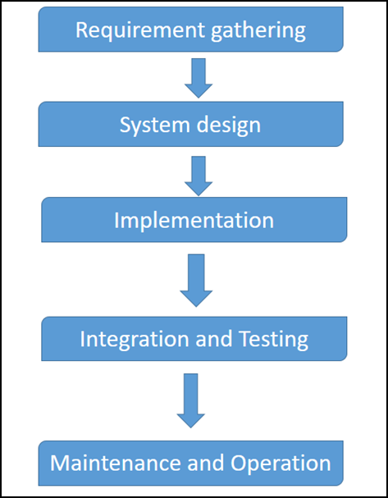

Figure 3.1: Waterfall Methodology Steps

### Requirement Gathering and analysis

All possible requirements of the system to be developed will be captured in this stage captured in this phase and documented in a requirement specification document. Observation will be used as a method of requirement gather because there is a need to understand how data flow when a patient visits a doctor. Interview method of data collection will also be used. Interview will help interviewees such as a doctor to vividly explain their technical answers.

### System Design

The requirement specifications from first phase are studied in this phase and the system design is prepared. This system design helps in specifying hardware and system requirements and helps in defining the overall system architecture. The requirement specifications from first phase will be studied in this phase and the system design is prepared. This system design will helps in specifying hardware and system requirements and helps in defining the overall system architecture.

### Implementation

With inputs from the system design, the system is first developed in small programs called units, which are integrated in the next phase. Each unit will be developed and tested for its functionality, which is referred to as Unit Testing. Some of the tools that will be used for Software Development/Implementation are Android studio, for mobile Application development, Web Storm for web application Development, MySQL Workbench for Tool that integrates SQL development, administration, database design and creation, WAMPP for Web application development

### Integration and Testing

In this stage all the units developed in the implementation phase will be integrated into a system after testing of each unit. In post integration the entire system will be tested for any faults and failures.

## Data Collection

In this phase the facts and requirements about the medical record systems are gathered. Sources of information during the requirements discovery phase included system stakeholders through

* Interview method
* Questionnaire
* Observation method
* Documentations of specifications of similar system.

### Interview

Interviews is a method of data collection that is designed to collect a richer source of information from a small number of people about opinions, attribute, and behavior, preferences as well as knowledge (Kumar, 2005). Interview was one of the methods used for requirements gathering.

Reason for using interview on this project:

1. Most data collection questions in this project are open ended, such as *what data is required for diagnosis* hence interview will enable collection of that in-depth information and help in clarifying if the interviewee doesn’t understand.
2. Interview will provide more room for the doctors to explain their answers

One-to-one interviews was conducted by asking different types of open-ended questions followed by subtle probing to elucidate clear system requirements. Below are sample questions and their responses:

### Observation

Observation is a systematic data collection approach. It involves the use of all human senses to examine people in natural settings or naturally occurring situations.

Reason for using observation:

1. It is important to study a phenomenon in its natural setting, how medical data flow from one point to another
2. The nature of the questions to be answered is focused on answering a how or what question for example how is the data record in order to get an idea on what kind of interface will be convenient in such settings.

In this project observation was used to examine patient interaction with health service providers such as doctor and lab technician at UDSM dispensary. The following diagram illustrate what was observed.

# CHAPTER FOUR: PIMM SYSTEM ANALYSIS AND DESIGN

## Requirement Specification for PIMM

From the data which were collected from the system stake holders through data collection methods mentioned in chapter three, they were analyzed very careful in order to obtain the requirement of the users and to see how the system will work then the software requirement specification document was produced as follows.

### PIMM Functional Requirements

The following in Table 4.1 are the functional requirement table of the Pharmaceutical Inventory Management Module.

Table 4.1: PIMM Functional Requirements

|  |  |
| --- | --- |
| **Code** | **Requirement** |
| FR-A1 FR-D1 | All medicine/drugs information shall be recorded in the system in order to monitor and manage the drugs stock inventory |
| FR-A1 FR-D2 | Doctor shall see all the available drugs in the hospital pharmacy that was filled in category |
| FR-A1 FR-D3 | Patient shall be able to request or buy drugs to any registered pharmacy |
| FR-D12 | Health care experts such as doctors and lab technicians shall be able to record relevant information e.g. lab technician shall be able to record lab test results in a service form |
| FR-A1 FR-D5 | Doctor shall be able to access demographic and medical checkup information such as full name and address from patient’s store and medical checkup from laboratory |
| FR-A1 FR-D6 | A Pharmacy staff shall be able to view all assigned drugs service forms, When a patient visits a health facility, which will contain records for a particular visit, such as lab tests, diagnosis, prescriptions etc. |
| FR-D7 | Patient shall be able to request drugs to the registered pharmacy |
| FR-D8 | Pharmacist, shall be able to use service form id to access a service form |
| FR-D9 | Service forms shall contain payment information |
| FR-D10 | Center in charge shall be able to add and manage the pharmacist |

#### 

### Non Functional Requirements

#### Usability

The System shall provide informational resources to help healthcare consumers understand any information within the medical record. A user shall be able to install and operate the program without assistance of any kind. The main use cases shall be accessible from a noticeable left or top navigation bar.

#### Compatibility

Client programs (Mobile Apps, Web Apps) shall be able to interact with the databank server without any changes to the server code

#### Responsiveness

The response time for operation is extremely short. Query response time must be fast. All queries must return a response in less than 2 seconds.

#### Securi**t**y

The system provides the authentication of users who need to perform administration tasks by login first. Only registered user should be able to view medical records. The passwords should be stored in encrypted form

### Use Case Analysis

Based on the above requirements, then the following are how the user will be interacting with  
the system. Figures 4.1, 4.2, 4.3 and 4.4 shows use case diagrams for the patient, Hospital/Pharmacy in-charge, Doctor and Pharmacist actors respectively.

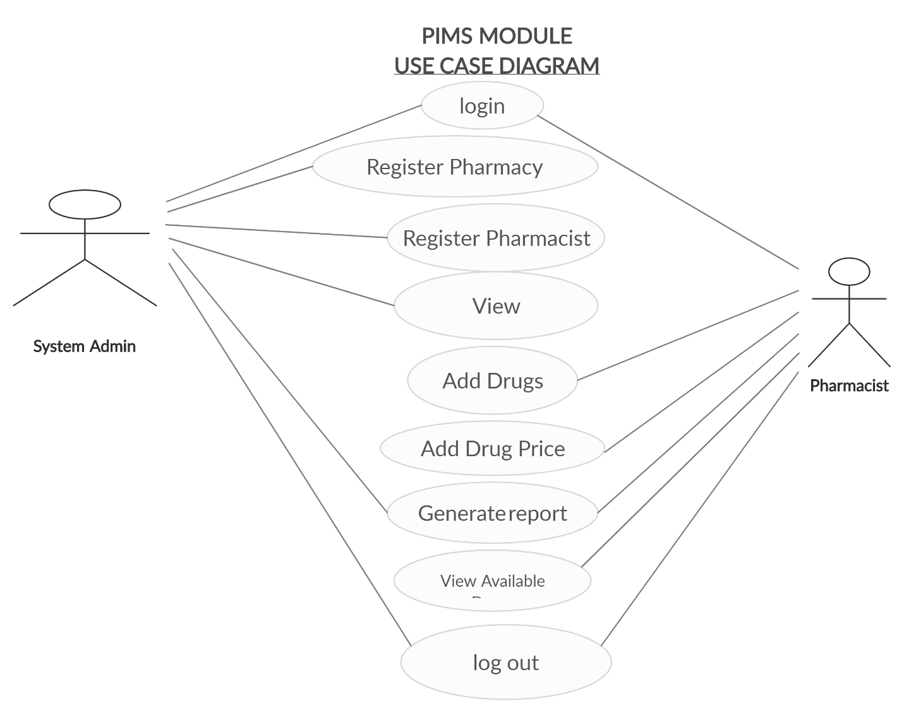

Figure 4.1: Use case diagram for System Admin and Pharmacist

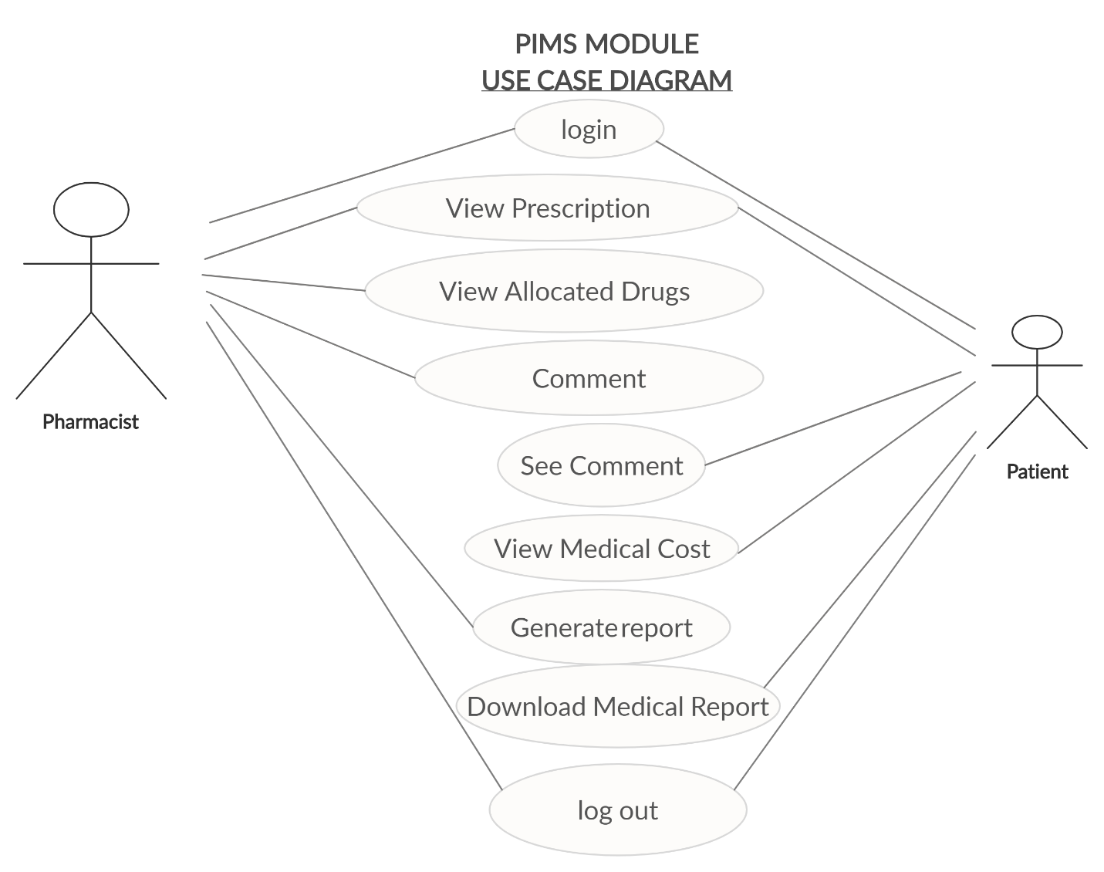

Figure 4.2 Use Case Diagram for Pharmacist and Patient

### Use cases descriptions

**Use case: View allocated drugs**

**Actors:** Patient

**Requirement:** A user should be registered

**Inputs:**  medicine detail from the doctor

**Outputs**: Service Form with the allocated drugs

**Normal operation:** The user will have to log in on either mobile application or web application in order to view medical and medicine information

**Use case: view medicine price**

**Actors:** Patient  
**Inputs:**  Selected drugs by doctor

**Outputs**: Price of the medicine that allocated

**Requirement**: A user should be logged in to the system in order to view price

**Use case: Select payment method**

**Actors:** Patient

**Inputs:**  payment method type (i.e. sponsors, cash)

**Outputs**: A payment confirmation message

**Requirement**: A user should be logged in

**Normal operation:**  The user will log in the system in order to select payment method

**Use case: view total medical cost**

**Actors:** Patient  
**Inputs:**  Unique access token for paying cost  
**Outputs**: Store information  
**Requirement**: A user should paying cost

**Use case: Allocate drugs**

**Actors: Doctors**  
**Inputs:**  Allocated drugs from doctor   
**Outputs**: A valid Service form with allocated drugs  
**Requirement**: A system should be active  
**Normal operation:**  The user will use patient’s unique access token to requesting a medicine in pharmacy.

**Use case: Register pharmacist**

**Actors:** Hospital/pharmacy admin  
**Inputs:**  Pharmacist detail  
**Outputs**: pharmacist information

**Use case: Allocate drugs price**

**Actors:** Hospital/pharmacy in charge  
**Inputs:**  drug price  
**Outputs**: list of drugs and its price.

**Use case: Add drugs**

**Actors:** Hospital/pharmacy in charge  
**Inputs:**  Drugs detail (category, type, name, id, expire date)  
**Outputs**: list of drugs registered  
**Requirement**: Details of each drugs (Downloadable PDF file) .

**Use case: Generate inventory report**

**Actors:** Hospital/pharmacy In charge  
**Inputs:**  report type (i.e. remain drugs, bought drugs, expired drugs, etc.)  
**Outputs**: Report generated.

**Use case: View available drugs**

**Actors:** Doctor  
**Inputs:**  Filled drugs in the system  
**Outputs**: List of available drugs

**Use case: select medicine**

**Actors:** Doctor  
**Inputs:**  Selection tools  
**Outputs**: allocate drugs in the patient for

**Use case: Allocate Patient Medicine**

**Actors:** Doctor  
**Inputs:**  selected allocated drugs  
**Outputs**: patient see the allocated drugs.

**Use case: Request medicine in stock/pharmacy**

**Actors:** Doctor  
**Inputs:**  use unique id of the patient to request drugs for helping patient to get drugs  
**Outputs**: inventory record the requested drugs and reduce stock items requested

**Use case: View requested Drugs**

**Actors:** Pharmacist  
**Inputs:**  Automatic system show requested drugs  
**Outputs**: Serve the patient requirement.

**Use case: Serve Patient request**

**Actors:** Pharmacist  
**Inputs:**  Verified Payment   
**Outputs**: system Show massage of patient payment.

**Use case: View patient price for allocated drugs**

**Actors:** Pharmacist  
**Inputs:** Allocated list of drugs with its total price.

### Class diagram analysis

Based on the above requirements, then the following are class diagram of the system

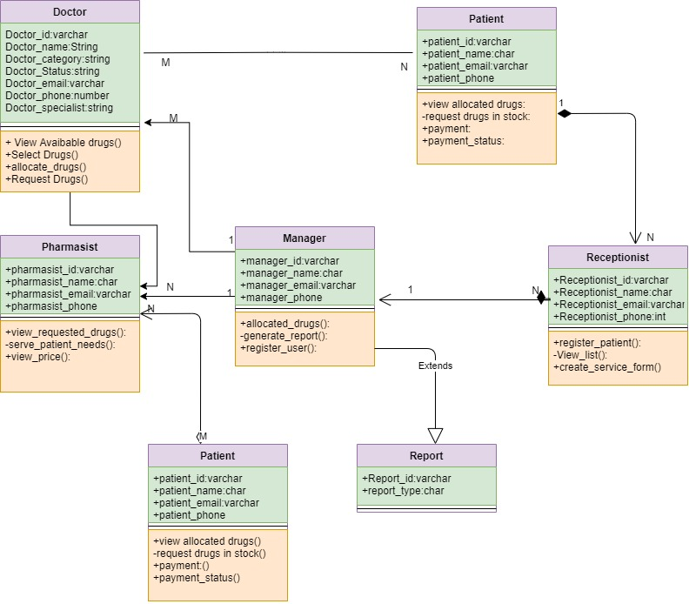

Figure 4.5: Class Diagram

## System Design

The system was designed with the aid of Unified Modeling Language (UML). The UML is a graphical language for specifying, visualizing, constructing and documenting the artifact of software systems. Different features to be presented which gives a view of a system that emphasizes the behavior as it appears to outside users.

### Data Modeling

Data modeling process involved creating a data model for the data to be stored in a Database. This data model is a conceptual representation of Data objects, the association between different data objects and the rules (Bong, 2014).

### Data Flow

Data flow is a flow of a data of a process or a system (information system). The DFD was used to provide information about the outputs and inputs of each entity and the process itself. Figures 4.3 and 4.4 are data flow diagrams.

1. DFD level 0

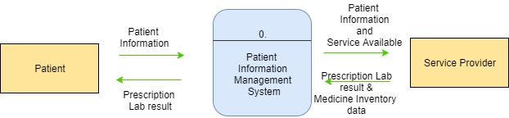

Figure 4.3: Level 0 Data Flow Diagram

1. DFD Level 1

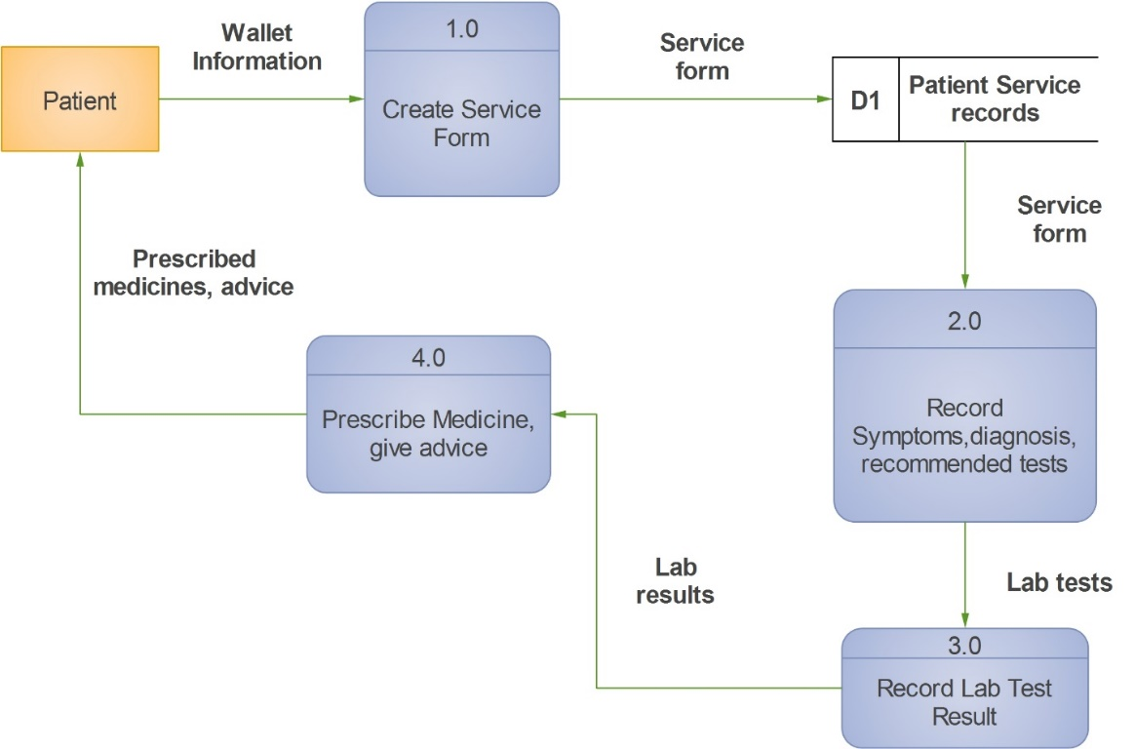

Figure 4.4: Level 1 Data Flow Diagram

### Entity Relationship Diagram

The main aim of this model is to establish the entities, their attributes, and their relationships

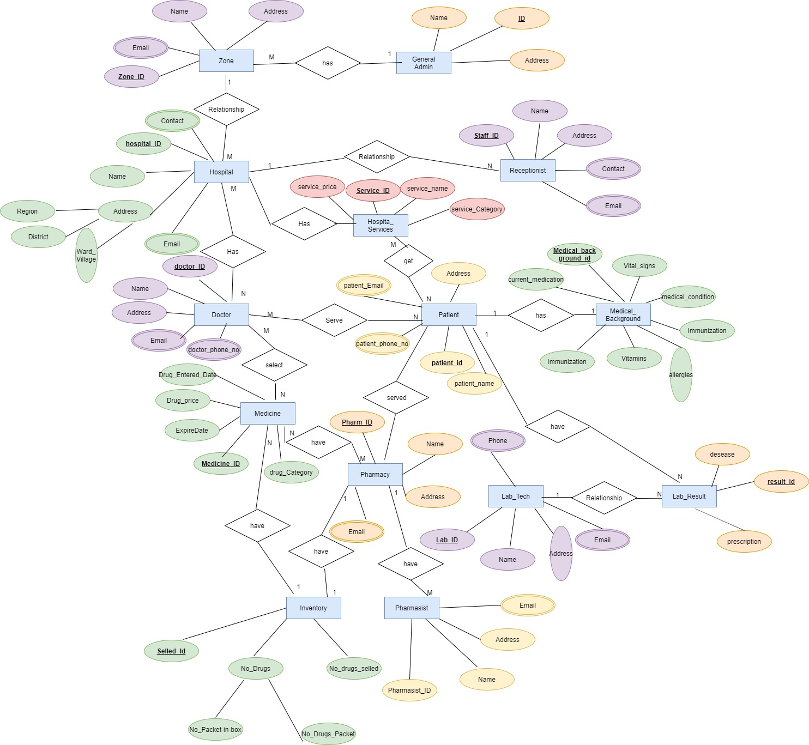

Figure 4.5: Entity Relationship Diagram for a Conceptual Database Model

### Activity Diagram

Activity diagram was used to capture the dynamic behavior of the system. Activity is a particular operation of the system. Activity diagrams was not only used for visualizing the dynamic nature of a system, but also used to construct the executable system by using forward and reverse engineering techniques.

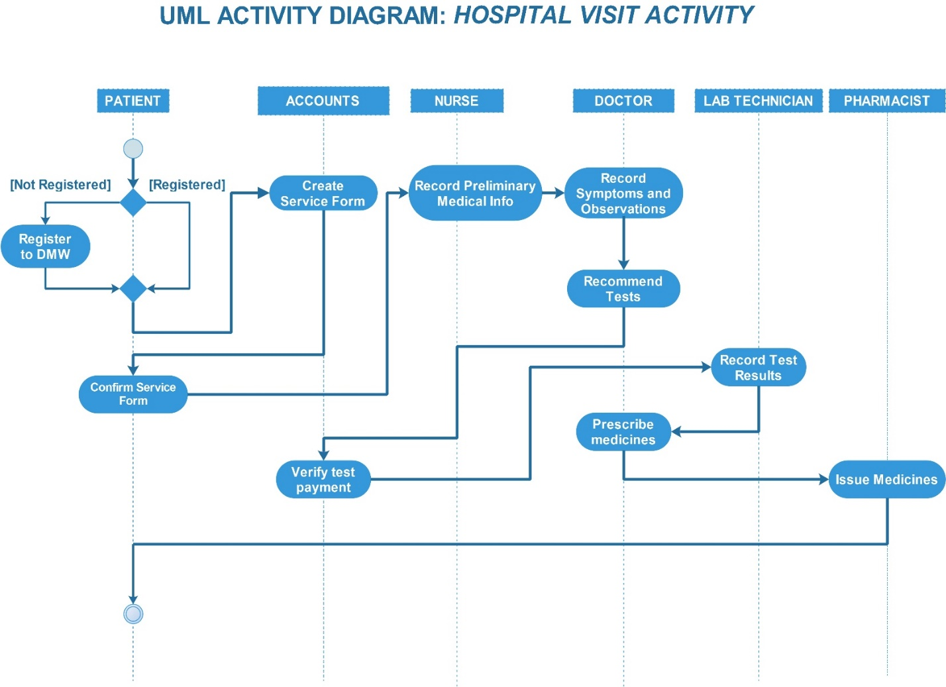

Figure 4.7: Activity Diagram for Hospital Visit

# CHAPTER FIVE: CONCLUSION AND RECOMMENDATIONS

## Conclusion

This project has turned out to be challenging in many ways. Each stage has presented its own  
problems to be overcome. All objectives according to the specified scope has been achieved.

One of the. The system has been tested and worked as expected. The testing was done on local servers with medium specifications. In order for it to be deployed for large scale use high performance servers will be required.

## Recommendations

I would like to recommend that for anyone who is willing to develop further this project has to  
consider implementing Magnetic stripe ID cards, also known as magstripe cards, are PVC ID cards containing a band of magnetic material embedded in the resin on the back of the card. Magnetic stripe ID cards store updatable information on a magstripe, which is read when the card is swiped through a magnetic stripe card reader. These card can be used to access patient wallets information more conveniently.

# REFERENCES

Ayres, F. (2018, December 20). *Gallagher Healthcare*. Retrieved from Gallaghermal Practice: https://gallaghermalpractice.com/blog/post/advantages-and-disadvantages-of-electronic-health-records

Bong, E. (2014, April 26). *Conceptual, Logical, & Physical Data Models* . Retrieved from guru: https://www.guru99.com/data-modelling-conceptual-logical.html

Kumar, R. (2005). *RESEARCH METHODOLOGY.* New Delhi: SAGE Publications Ltd.

Muhimbili National Hospital. (2018, January 3). *Medical Records*. Retrieved from Muhimbili National Hospital: http://www.mnh.or.tz/index.php/directorates/information-communication-technology/medical-records

National Center for Accessible Media. (2018, November 30). *Accessible design for medical health records*. Retrieved from Health Access: http://healthitaccess.wgbh.org/functional-requirements.html

WHO. (2006). *Medical Records Manual.* Western Pasific Region: World Health Organization.

# APPENDICES

## Appendix I: Project Schedule

|  |  |  |  |  |  |  |  |
| --- | --- | --- | --- | --- | --- | --- | --- |
|  | DEC | JAN  1St week | JAN  2nd week | JAN  3rd and 4th week | JAN  5th week | FEB  1st week | FEB |
| A |  |  |  |  |  |  |  |
| B |  |  |  |  |  |  |  |
| C |  |  |  |  |  |  |  |
| D |  |  |  |  |  |  |  |
| E |  |  |  |  |  |  |  |

KEY:

A: Regrouped Title

B: Literature Review

C: Data Collection

D: Data Analysis

E: System Design and Analysis

## Appendix II: Estimated Cost of the project

|  |  |  |
| --- | --- | --- |
| ITEM | QUANTITY | AMOUNT (TSH) |
| Internet | 20GB | 30,000 |
| Reports | 6 | 54,000 |
| DVDs | 2 | 4,000 |
| Contingency |  | 50,000 |
| Transport |  | 30,000 |
| Emergence |  | 50000 |
| TOTAL | | 218,000 |

## Appendix III: Sample Interview questions (interview with a physician)

**Question 1**

What patient medical records are essential for accurate diagnosis and treatment plans?

**Purpose of the question:**

To get information that will facilitate the database design process

**Response**

*Good clinical records will contain all the information one clinician needs to take over where another left off or, to put it another way, to allow a clinician to reconstruct a consultation or patient contact without relying on memory. This will include:*

* *Physical examination of the patient*
* *All important findings, both positive and negative, with details of any objective measurement such as blood pressure, peak flow, etc.*
* *Information given to the patient concerning risks and benefits of proposed treatments*
* *Treatment details of the main doses of drugs, total amount prescribed*
* *Progress the patient’s current condition, medicine side effects etc.*
* *Immunizations information*
* *Allergies*
* *Disorder and complications*

**Question 2**

Is there any medical information which a patient is not supposed to have/see?

**Purpose of the question:**

To see if there is a need to put access control levels in the new system

**Response**: *Yes*

(If yes) What Medical information has to be kept from the patient?

**Response**: *Results for sensitive diagnosis is one instance of sensitive information that should be kept form the patient, patient can only receive the result after counseling*